Project Report
On
HOSTELMATE-HOSTEL ALLOTMENT SYSTEM
Report submitted in partial fulfilment
Of
the requirement for the degree
of
B.Tech.
In

Computer Science & Engineering
Under the Supervision of

Respected Kumar Saurabh (Assistant Professor CSE Department)
By

Atharva Bhatnagar (2001640100078)

Pranveer Singh Institute of Technology, Kanpur
Affiliated to
Dr. A. P. J. Abdul Kalam Technical University
Lucknow, Uttar Pradesh

Certificate

This is to certify that the Project Report entitled Hostelmate which is submitted by Atharva Bhatnagar bearing Roll No. 2001640100078 in partial fulfilment of the requirement for the award of degree of Computer Science and Engineering of Pranveer Singh Institute of Technology, affiliated to Dr. A. P. J. Abdul Kalam Technical University, Lucknow is a record of the candidate’s own work carried out by her under my supervision. The project embodies result of original work and studies original work and studies carried out by the student herself and the contents of the project do not form the basis for the award of any other degree to the candidate or to anybody else.

Signature:  Dr Vishal Nagar  Head of Department  CSE Department,  PSIT, Kanpur |  | Signature:  Respected Kumar Saurabh  Assistant Professor  CSE Department,  PSIT, Kanpur

Date:19-02-2022

COURSE CERTIFICATION

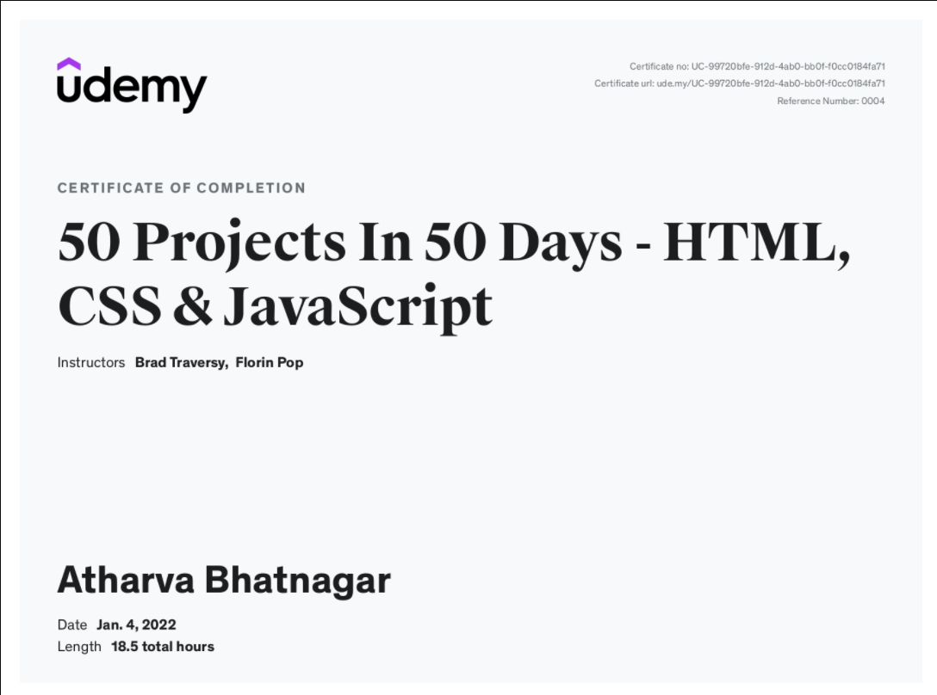

DECLARATION

We hereby declare that this submission is our own work and that, to the best of my knowledge and belief, it contains no material previously published or written by another person nor material which to a substantial extent has been accepted for the award of any other degree or diploma of the university or other institute of higher learning, except where due acknowledgment has been made in the text.

Atharva Bhatnagar
Computer Science and Engineering
Roll No. - 2001640100078
CS -2-A
PSIT

ACKNOWLEDGEMENT

It gives us a great sense of pleasure to present the report of the B.Tech. Project undertaken during B.Tech. Second Year(Third Semester). We owe special debt of gratitude to our project supervisor Respected Kumar Saurabh Sir, Department of Computer Science and Engineering, Pranveer Singh Institute of Technology, Kanpur for his constant support and guidance throughout the course of our work. His sincerely, thoroughness and perseverance have been a constant source of inspiration for us. It is only his cognizant efforts that our endeavours have seen light of the day.
We also take the opportunity to acknowledge the contribution of Professor Dr Vishal Nagar, Head, Department of Computer Science & Engineering, Pranveer Singh Institute of Technology, Kanpur for his full support and assistance during the development of the project.
We also do not like to miss the opportunity to acknowledge the contribution of all faculty members of the department for their kind assistance and cooperation during the development of our project. Last but not the least, we acknowledge our family and friends for their contribution in the completion of the project.

Atharva Bhatnagar
Computer Science and Engineering
Roll No. - 2001640100078
CS -2-A
PSIT

ABSTRACT

As the name specifies “HOSTELMATE” is a web-based application developed for managing the hostel room allotment process. For the past few years, the number of educational institutions has been increased rapidly. Thereby the number of hostels is also increasing for the accommodation of the students studying in those institutions. And as the number of students studying in these institutes and are increasing day by day so the process of allotment of hostel is a very tiring and cumbersome task which may consume a lot of time and people. This particular project deals with the problems of allocation of hostel rooms on a first come first serve basis and rather allocating them in a data driven manner thereby avoiding the problems which occur when the allotment of the hostel rooms is carried out in an orthodox manual fashion. Identification of the drawbacks of the existing system leads to the designing of computerized system that will be compatible to the existing system with the system Which is more user friendly and more GUI oriented.
We can improve the efficiency of the system, thus overcome the following drawbacks of the existing system:
. Less human error.
· Strength and strain of manual labour can be reduced · High security.
· Data redundancy can be avoided to some extent· Data consistency·
. Easy record keeping·
. Backup data can be easily generated.

TABLE OF CONTENTS
Chapter Page
1. Introduction…………………………………………………………………………………………… 7
1.1 Project Overview……………………………………………………………………………………………………. 7
1.2 Motivation…………………………………………………………………………………………………………………… 8
1.3 Project Scope……………………………………………………………………………………………………………. 8
1.4 Project Objective……………………………………………………………………………………………………………. 8
2. System Requirements…………………………………………… 9
2.1 Hardware Requirements…………………………………………………………… 9
2.2 Software Requirements…………………………………………………………… 9
3. Design and Implementation………………………………… 15
3.1 Front End………………………………………………………………………………… 15
3.2 Back End………………………………………………………………………………… 15
4. Testing/Result and Analysis………………………………… 28
5. Conclusions and Future Enhancements……………… 32
5.1 Advantages of Software…………………………………………………………… 32
5.2 Disadvantages…………………………………………………………………………. 32
5.3 Future Enhancements…………………………………………... 33
5.4 Conclusion…………………………………………………….... 34

- INTRODUCTION

1.1 Project Overview:
This project is basically a web-based responsive application which will aid in improvising the process of allotment of hostel-rooms which are currently allocated in a random manner based on first come first serve basics thereby helping to solve a real-life problem of allotment of hostel rooms in a structured and centralised manner.

How does Hostelmate work?

The students are required to fill a web-based form which have some personalized questions which will help in identifying the nature and interests of the students. Then this form submitted by the user will be stored in the backend using XAMPP server and using the XAMPP server we will manipulate and sort the students data based on semester marks so as to categories them accordingly and then the student’s data will be exported to MS-EDGE where we will display the prepared chart for hostel room allotment.

Why should you use HostelMate?

Like all forms of technology, this has many benefits that help us improve daily processes. These are some of the main advantages of using this project are:
- Save time: Automatic allotment of hostel rooms without manual labour saves time
- Cost-efficient: Allotment of hostel rooms manually involves a lot of labour and the owner has to bear this cost using this hostelmate project will reduce this type of cost from the owner’s perspective
- Data Based Allotment of Hostel Rooms: Using this project the user can make sure that the hostel rooms are allocated based on students’ data and the students having similar interests and nature are allocated the same room.
- Easy Management: Using this project the allotment will be done on the basis of nature and interests of students this will also benefit in the management of the hostel in a more efficient manner as the students with similar nature will be localised and hence the warden can deal with them accordingly.

1.2 Motivation:

With the increase in number of students, the number of educational institutes as well as the number of hostels required to accommodate the students are also increasing and with increase in the number of hostels as well as students there seemed an urgent need for an application for the process of allotment of hostel rooms in an efficient manner based on students’ data rather than the orthodox first come first serve basis

1.3 Project Scope:
Currently this project is used for the allocation of hostels in educational institutes based on the data of the students. This project can be further modified and extended for the process of allotment of rental rooms in a PG based on the data of the client as well as this can also be extended for the allotment of hostels in military bases.

  - Project Objective:
  - India is regarded as the next growth engine of the world, being one of the youngest nations globally, waiting for its demographic dividend to materialise. Almost all commentators agree that if given the right platforms and opportunities, India can tap into the gold mine of human resources.
  - India saw significant investment in higher education institutions in the decade following Independence.
. Of course, with the increasing population and a huge demand for catering to the growing pool of students, there has always been a struggle between investing in new institutions and supporting existing ones with more resources.
. As the number of educational institutes are increasing the number of hostels is also increasing and with the increase in number of hostels the need of a hostel allotment system also increases.

2.SYSTEM REQUIREMENTS:

2.1 HARDWARE REQUIREMENT:

The section of hardware configuration is an important task related to the software development insufficient random-access memory may affect adversely on the speed and efficiency of the entire system. The process should be powerful to handle the entire operations. The hard disk should have sufficient capacity to store the file and application.
The hardware requirements of the project are as follows:
1. Minimum 4 GB of RAM
2. x86 or AMD64 CPU with at least one core

2.2 SOFTWARE REQUIREMENT:
The software requirements of this project as listed as below:
1. HTML
2. CSS
3. PHP
4. XAMPP SERVER
5. MS-EDGE
6. Visual Studio Code
7. CHROME WEB BROWSER

2.2.1 HTML
The Hyper Text Markup Language, or HTML is the standard markup language for documents designed to be displayed in a web browser. It can be assisted by technologies such as Cascading Style Sheets (CSS) and scripting languages such as JavaScript.
Web browsers receive HTML documents from a web server or from local storage and render the documents into multimedia web pages. HTML describes the structure of a web page semantically and originally included cues for the appearance of the document.
HTML elements are the building blocks of HTML pages. With HTML constructs, images and other objects such as interactive forms may be embedded into the rendered page. HTML provides a means to create structured documents by denoting structural semantics for text such as headings, paragraphs, lists, links, quotes and other items. HTML elements are delineated by tags, written using angle brackets. Tags such as <img /> and <input /> directly introduce content into the page. Other tags such as <p> surround and provide information about document text and may include other tags as sub-elements. Browsers do not display the HTML tags, but use them to interpret the content of the page.

2.2.2 CSS
Cascading Style Sheets (CSS) is a style sheet language used for describing the presentation of a document written in a markup language such as HTML. CSS is a cornerstone technology of the World Wide Web, alongside HTML and JavaScript.
CSS is designed to enable the separation of presentation and content, including layout, colours, and fonts. This separation can improve content accessibility; provide more flexibility and control in the specification of presentation characteristics; enable multiple web pages to share formatting by specifying the relevant CSS in a separate . CSS file, which reduces complexity and repetition in the structural content; and enable the CSS file to be cached to improve the page load speed between the pages that share the file and its formatting.
Separation of formatting and content also makes it feasible to present the same markup page in different styles for different rendering methods, such as on-screen, in print, by voice (via speech-based browser or screen reader), and on Braille-based tactile devices. CSS also has rules for alternate formatting if the content is accessed on a mobile device.
The name cascading comes from the specified priority scheme to determine which style rule applies if more than one rule matches a particular element. This cascading priority scheme is predictable.

2.2.3 PHP
PHP is a scripting language originally designed for producing dynamic web pages. It has evolved to include a command line interface capability and can be used in standalone graphical applications. While PHP was originally created by Rasmus Leadoff in 1995, the main implementation of PHP is now produced by The PHP Group and serves as the de facto standard for PHP as there is no formal specification. PHP is free software released under the PHP License, however it is incompatible with the GNU General Public License
(GPL), due to restrictions on the usage of the term PHP. It is a widely-used general-purpose scripting language that is especially suited for web development and can be embedded into HTML. It generally runs on a webserver, taking PHP code as its input and creating web pages as output. It can be deployed on most web servers and on almost every operating system and platform free of charge. PHP is installed on more than 20 million websites and 1 million web servers. PHP is a general-purpose scripting language that is especially suited for web development. PHP generally runs on a web server, taking PHP code as its input and creating web pages as output. It can also be used for command-line scripting and client-side GUI applications. PHP can be deployed on most web servers, many operating systems and platforms, and can be used with many relational database management systems. It is available free of charge, and the PHP Group provides the complete source code for users to build, customize and extend for their own use. PHP primarily acts as a filter, taking input from a file or stream containing text and/or PHP instructions and outputs another stream of data; most commonly the output will be HTML. It can automatically detect the language of the user. From PHP 4, the PHP parser compiles input to produce bytecode for processing by the Zend Engine, giving improved performance over its interpreter predecessor. Originally designed to create dynamic web pages, PHP’s principal focus is server-side scripting, and it is similar to other server-side scripting

2.2.4 MYSQL
What is a database? Quite simply, it’s an organized collection of data. A database management system(DBMS) such as Access, FileMaker Pro, Oracle or SQL Server provides you with the software tools you need to organize that data in a flexible manner. It includes facilities to add, modify or delete data from the database, ask questions (or queries) about the data stored in the database and produce reports summarizing selected contents. MySQL is a multithreaded, multiuser SQL database management system (DBMS). The basic program runs as a server providing multi-user access to a number of databases. Originally financed in a similar fashion to the JBoss model, MySQL was owned and sponsored by a single for-profit firm, the Swedish company MySQL now a subsidiary of Sun Microsystem, which holds the copyright to most of the codebase. The project’s source code is available under terms of the GNU General Public Licence, as well as under a variety of proprietary agreements. MySQL is a database. The data in MySQL is stored in database objects called tables. A table is a collections of related data entries and it consists of columns and rows. Databases are useful when storing information categorically. A company may have a database with the following tables: “Employees”, “Products”, “Customers” and “Orders”.
2.2.5 phpMyAdmin

phpMyAdmin is an open-source tool written in PHP intended to handle the administration of MySQL over the World Wide Web. phpMyAdmin supports a wide range of operations with MySQL. Currently it can create and drop databases, create/drop/alter tables, delete/edit/add fields, execute any SQL statement, manage users and permissions, and manage keys on fields. while you still have the ability to directly execute any SQL statement. phpMyAdmin can manage a whole MySQL server (needs a super-user) as well as a single database. To accomplish the latter you’ll need a properly set up MySQL user who can read/write only the desired database. It’s up to you to look up the appropriate part in the MySQL manual.
phpMyAdmin can:
·browse and drop databases, tables, views, fields and indexes create, copy, drop, rename and alter databases, tables, fields and indexes maintenance server, databases and tables, with proposals on server configuration execute, edit and bookmark any SQL-statement, even batch- queries ·load text files into tables·create and read dumps of tables export data to various formats: CSV, XML, PDF, ISO/IEC 26300 - OpenDocument Text and Spreadsheet, Word, Excel and LATEX formats administer multiple servers manage MySQL users and privileges check referential integrity in My ISAM tables using Query-by-example (QBE), create complex queries automatically connecting required tables·create PDF graphics of your Database layout search globally in a database or a subset of it transform stored data into any format using a set of predefined functions, like displaying BLOB- data as image or download-link ·support Inorb tables and foreign keys support MySQL, the improved MySQL extensions.

2.2.6 Visual Studio Code
Visual Studio Code is a source-code editor made
by Microsoft for Windows, Linux and macOS. Features include support for debugging, syntax highlighting, intelligent code completion, snippets, code refactoring, and embedded Git. Users can change the theme, keyboard shortcuts, preferences, and install extensions that add additional functionality.
In the Stack Overflow 2021 Developer Survey, Visual Studio Code was ranked the most popular developer environment tool, with 70% of 82,000 respondents reporting that they use it.

2.2.7 Apache Web Server

Apache, a public-domain open source Web server developed by a loosely-knit group of programmers. The first version of Apache, based on the NCSA httpd Web server, was developed in 1995.Core development of the Apache Web server is performed by a group of about 20 volunteer programmers, called the Apache Group. However, because the source code is freely available, anyone can adapt the server for specific needs, and there is a large public library of Apache add-ons. In many respects, development of Apache is similar to development of the Linux operating system. The original version of Apache was written for UNIX, but there are now versions that run under OS/2, Windows and other platforms. The name is a tribute to the Native American Apache Indian tribe, a tribe well-known for its endurance and skill in warfare. A common misunderstanding is that it was called Apache because it was developed from existing NCSA code plus various patches, hence the name a patchy server, or Apache server. Apache consistently rates as the world’s most popular Web server according to analyst surveys. Apache has attracted so much interest because it is full-featured, reliable, and free. Originally developed for UNIX™ operating systems, Apache has been updated to run on Windows, OS/2, and other platforms. One aspect of Apache that some site administrators find confusing — especially those unfamiliar with UNIX-style software — is its configuration scheme. Instead of using a point-and-click graphic user interface (GUI) or Windows Registry keys as most other modern software packages, Apache generally relies on simple text files for its configuration settings

3.DESIGN AND IMPLEMENTATION

METHODOLOGY:

Inputting the student’s data in the Html and CSS based web form
Redirecting the data to XAMPP server using php storing the data in the data base using XAMPP server

In the XAMPP server we are processing the data and sorting it on basis of marks and then exported in pdf form to MS-EDGE
The data is exported in the form of pdf to Microsoft edge and from there we can take the print out and use that sheet for hostel allotment process.

3.1 Front End
3.1.1 Using an Html and CSS based web form to take input from the student

3.2 Back End
3.2.1 Php: In the Back End I have used php to redirect the data submitted to XAMPP server from where all our operations are taking place
3.2.2 XAMPP Server: This is the backbone of our project and this is used for storing ,updating as well as manipulating the data which will be displayed as pdf
3.2.3 Microsoft-Edge: The processed data from the XAMPP server is directed to Microsoft edge and is used to display the output in the table format

PROJECT CODE

^{HTML, CSS, PHP CODE}
^{html}
{
font-family: 'Gill Sans', 'Gill Sans MT', Calibri, 'Trebuchet MS', sans-serif;
}
^{body}
{
^{background-color :#20bf55;}
background-image :linear-gradient(315deg, #20bf55 0%, #01baef 74%);
^{width: 100vw;}
^{height: 100vh;}
}
^{h1{}
^{border-top-style: solid;}
^{border-bottom-style: solid;}
border-color: rgb(12, 170, 59) solid;
^{border-width: 3px;}
^{padding-left: 5px;}
font-family: "Courier New", Courier, monospace;
^{text-align: center;}
^{background-color: black;}
^{color: white;}
}
^{#hobbies}
{
^{display: flex;}
^{flex-direction: row;}
^{flex-wrap: wrap;}
^{justify-content: space-evenly;}
^{font-size: 1.5rem;}
^{margin-top: 10vh;}
}
^{#gender}
{
^{font-size: 1.5rem;}
^{margin-left: 3.5rem;}
^{margin-bottom: 1.5rem;}
}
^{#info}
{
^{display: flex;}
^{flex-direction: row;}
^{flex-wrap: wrap;}
^{justify-content: space-evenly;}
^{font-size: 1.5rem;}
^{margin-top: 10vh;}
^{margin-bottom: 1.5rem;}
}
^{#em,#dob,#int,#ge,#way}
^{{display: block;}
^{font-size: 1.5rem;}
^{margin-bottom: 1.1rem;}
}
^{.pref}
{
^{width: 100vw;}
^{margin-left: 5vw;}
^{margin-bottom: 5vh;}
^{margin-bottom: 2vh;}
}
^{input[type="radio"]}
{
^{transform: scale(1.5);}
}
input[type=text], select, textarea{
^{width: 100%;}
^{padding: 12px;}
border: 1px solid rgb(10, 10, 10);
^{border-radius: 4px;}
^{box-sizing: border-box;}
^{resize: vertical;}
^{background: #fdfbfb;}
^{/* margin-top: 1rem; */}
^{width: 70vw;}
}

^{input[type="email"]}
{
^{width: 30vw;}
^{height: 5vh;}
}
^{input[type="date"]}
{
^{width: 30vw;}
^{height: 5vh;}
}
^{label {}
^{font-size: x-large;}
^{padding: 12px 12px 12px 0;}
^{display: inline-block;}
}

^{#sub}
{
^{color: white;}
^{font-size: 1rem;}
}
^{#reset}
{
^{background-color: #ff4e00;}
background-image: linear-gradient(315deg, #ff4e00 0%, #ec9f05 74%);
^{padding: 12px 20px;}
^{border: none;}
^{border-radius: 4px;}
^{cursor: pointer;}
^{float: right;}
^{color: white;}
^{font-size: 1rem;}
}
^{#in-buttons}
{
^{display: flex;}
justify-content: space-between;
^{align-items: baseline;}
}
^{input[type=submit] {}
^{font-size: small;}
^{background-color: #0cbaba;}
background-image: linear-gradient(315deg, #0cbaba 0%, #380036 74%);

^{color: rgb(20, 19, 19);}

^{padding: 12px 20px;}
^{border: none;}
^{border-radius: 4px;}
^{cursor: pointer;}
^{float: left;}
}

^{.container {}
^{border-radius: 5px;}
/* background-color:rgb(29, 113, 161); */
^{padding: 20px;}
^{color:black;}
}

^{.col-25 {}
^{float: left;}
^{width: 25%;}
^{margin-top: 6px;}
}

^{.col-75 {}
^{float: left;}
^{width: 75%;}
^{margin-top: 6px;}
}

/* Clear floats after the columns */
^{.row:after {}
^{content: "";}
^{display: table;}
^{clear: both;}
}

/* Responsive layout - when the screen is less than 600px wide, make the two columns stack on top of each other instead of next to each other */
@media screen and (max-width: 600px) {
.col-25, .col-75, input[type=submit] {
^{width: 100%;}
^{margin: 10%;}
^{margin-bottom: 0;}
}
^{#gender}
{

^{margin-left: 1rem;}

}
^{#hobbies}
{
^{flex-direction: column;}
^{justify-content: baseline;}
^{display: inline-block;}

}
}

^{input[type="number"]}
{
^{width: 100%;}
^{padding: 12px;}
border: 1px solid rgb(10, 10, 10);
^{border-radius: 4px;}
^{box-sizing: border-box;}
^{resize: vertical;}
^{background: #fdfbfb;}
^{/* margin-top: 1rem; */}
^{width: 70vw;}
}

^{<!DOCTYPE html>}
^{<html lang="en">}

^{<head>}
^{<meta charset="UTF-8">}
<meta http-equiv="X-UA-Compatible" content="IE=edge">
<meta name="viewport" content="width=device-width, initial-scale=1.0">
^{<title>HOSTEL MATE</title>}
<link rel="stylesheet" href="layout1.css">
^{</head>}

^{<body>}
<h1>HOSTEL ROOM ALLOTMENT FORM</h1>

<form action="entry_details.php" method="post">
^{<div class="container">}
<form action="action_page.php" method="post">
^{<div class="row">}
^{<div class="col-25">}
<label for="fname" >First Name</label>
^{</div>}
^{<div class="col-75">}
<input type="text" id="fname" name="firstname" placeholder="Your name.." maxlength="30" minlength="5" required>
^{</div>}
^{</div>}
^{<div class="row">}
^{<div class="col-25">}
<label for="lname">Last Name</label>
^{</div>}
^{<div class="col-75">}
<input type="text" id="lname" name="lastname" placeholder="Your last name.." maxlength="30" minlength="5" required>
^{</div>}
^{</div>}
^{<div class="row">}
^{<div class="col-25">}
<label for="Course">Course</label>

^{</div>}
^{<div class="col-75">}

<select name="myCourse" id="Course" required>
<option value="btech" selected>B-TECH</option>
^{<option value>M-TECH</option>}
<option value="bba">BBA</option>
<option value="mba">MBA</option>
<option value="bca">BCA</option>
<option value="mca">MCA</option>
^{</select>}
^{</div>}
^{</div>}
^{<div class="row">}
^{<div class="col-25">}
<label for="branch">Branch</label>

^{</div>}
^{<div class="col-75">}

<select name="mybranch" id="Branch" required>
<option value="cs" selected>CSE</option>
<option value="ec">ECE</option>
^{<option value="en">EN</option>}
^{<option value="ee">EE</option>}
^{<option value="me">ME</option>}
^{<option value="ce">CE</option>}
<option value="che">CHE</option>
<option value="oth">Other</option>
^{</select>}
^{</div>}
^{</div>}

^{<div class="row">}
^{<div class="col-25">}
<label for="marks">10th Percentage</label>
^{</div>}
^{<div class="col-75">}
<input type="number" min="0" max="100" id="marks" name="10thmarks" placeholder="Your marks..." required>
^{</div>}
^{</div>}
^{<div class="row">}
^{<div class="col-25">}
<label for="marks">12th Percentage</label>
^{</div>}
^{<div class="col-75">}
<input type="number" min="0" max="100" id="marks" name="12thmarks" placeholder="Your marks..." required>
^{</div>}
^{</div>}

^{<div class="row">}
^{<div class="col-25">}
<label for="marks">Last Semester SGPA</label>
^{</div>}
^{<div class="col-75">}
<input type="number" min="0" max="10" id="marks" name="lastsemestermarks" placeholder="Your marks..." required >
^{</div>}
^{</div>}
^{<div class="row">}
^{<div class="col-25">}
<label for="marks">Roll Number</label>
^{</div>}
^{<div class="col-75">}
<input type="number" id="roll number" name="rollnumber" placeholder="Your roll number..." maxlength="20" required>
^{</div>}
^{</div>}
^{<div class="row">}
^{<div class="col-25">}
<label for="marks">Section</label>
^{</div>}
^{<div class="col-75">}
<input type="text" id="section" name="section" placeholder="Your section..." maxlength="1" minlength="1" required>
^{</div>}
^{</div>}
^{</div>}

^{<div class="row">}
<div id="hobbies" name="hobbies" >
<span class="pref"> Hobbies:</span> <span>Sports</span> <input type="radio" name="hobbies" value="Sports" checked>
<span> Art</span> <input type="radio" name="hobbies" value="Art" >
<span> Indoor Games</span> <input type="radio" name="hobbies"value="Indoor Games" > <span> Others</span> <input type="radio" name="hobbies" value="Others" >
^{</div>}
^{</div>}
^{<br>}

^{<div class="row">}
<div id="info" name="mystudyhours" >
<span class="pref"> Prefered Study Hours:</span> <span>Early Morning</span> <input type="radio" name="mystudyhours" value="Early Morning" checked>

<span>Morning</span> <input type="radio" name="mystudyhours" value="Morning" >
<span>Night</span> <input type="radio" name="mystudyhours" value="Night" > <span>Late Night</span> <input type="radio" name="mystudyhours" value="Late Night" >
^{</div>}
^{</div>}
^{</br>}
^{<br>}

^{<div class="row">}
^{<div class="pref">}
<span id="int"> Interests:</span>
<textarea name="interests" id="" cols="30" rows="10" class="interest" maxlength="80" minlength="20" required>

^{</textarea>}
^{</div>}
^{</div>}
^{<br>}

^{<div class="row">}
^{<div class="pref">}

<span id="em"> Email:</span> <input type="email" name="email" placeholder="E-mail" maxlength="80" required>
^{</div>}
^{</div>}

^{<br>}

^{<div class="row">}
^{<div class="pref">}
<span id="dob"> DOB:</span> <input type="date" name="dob">
^{</div>}
^{</div>}

^{<br>}

^{<div class="row">}
^{<div id="gender" >}
<span id="ge"> Gender:</span> Male <input type="radio" name="gender" value="Male" checked>

Female <input type="radio" name="gender" value="Female">
Other <input type="radio" name="gender" value="Other" >
^{</div>}
^{</div>}

^{<br>}

^{<div class="row">}
^{<div class="pref">}
<span id="way"> Write about yourself:</span> <br><textarea name="aboutyou" cols="90" rows="10" maxlength="200" minlength="30" required></textarea>
^{</div>}
^{</div>}

^{<br>}

^{<div id="in-buttons">}
<input type="submit" name="Submit" value="submit" id="sub" >
<input type="reset" value="Reset Now" id="reset">
^{</div>}
^{</form>}
^{</body>}

^{</html>}

^{<?php}
if (isset($_POST['firstname'])){
^{$server="localhost";}
^{$username="root";}
^{$password="";}
$con=mysqli_connect($server,$username,$password);
^{if(!$con){}
die("Could not Connect MySql Server:" . mysqli_connect_error());
}

$firstname=$_POST['firstname'];
^{$lastname=$_POST['lastname'];}
^{$course=$_POST['myCourse'];}
^{$branch=$_POST['mybranch'];}
$tenthmarks=$_POST['10thmarks'];
$twelfthmarks=$_POST['12thmarks'];
$lastsemestermarks=$_POST['lastsemestermarks'];
$rollnumber=$_POST['rollnumber'];
^{$section=$_POST['section'];}
^{$hobbies=$_POST['hobbies'];}
$preferedstudyhours=$_POST['mystudyhours'];
$intersets=$_POST['interests'];
^{$email=$_POST['email'];}
^{$dob=$_POST['dob'];}
^{$gender=$_POST['gender'];}
^{$aboutyou=$_POST['aboutyou'];}

$sql="INSERT INTO `miniproject`.`miniprojectdata` (`firstname`, `lastname`, `mycourse`, `mybranch`, `10th_marks`, `12th_marks`, `last_semester_marks`, `roll_number`, `section`, `myHobbies`, `myStudyhours`, `interests`, `myEmail`, `myDate`, `myGender`, `myText`)
VALUES ('$firstname','$lastname','$course','$branch','$tenthmarks','$twelfthmarks','$lastsemestermarks','$rollnumber','$section','$hobbies','$preferedstudyhours','$intersets','$email','$dob','$gender','$aboutyou')";
^{// echo $sql;}

^{if($con->query($sql)==true)}
{
echo '<script>alert("Form Submitted Successfully")</script>';
}
^{else}
{
echo '<script>alert("Error While Submitting The Form Please Try again")</script>';
// echo "ERROR --> : $sql <br> $con->error";
}
^{$con->close();}
}
?>

4.Testing/Result and Analysis

Frontend And Backend

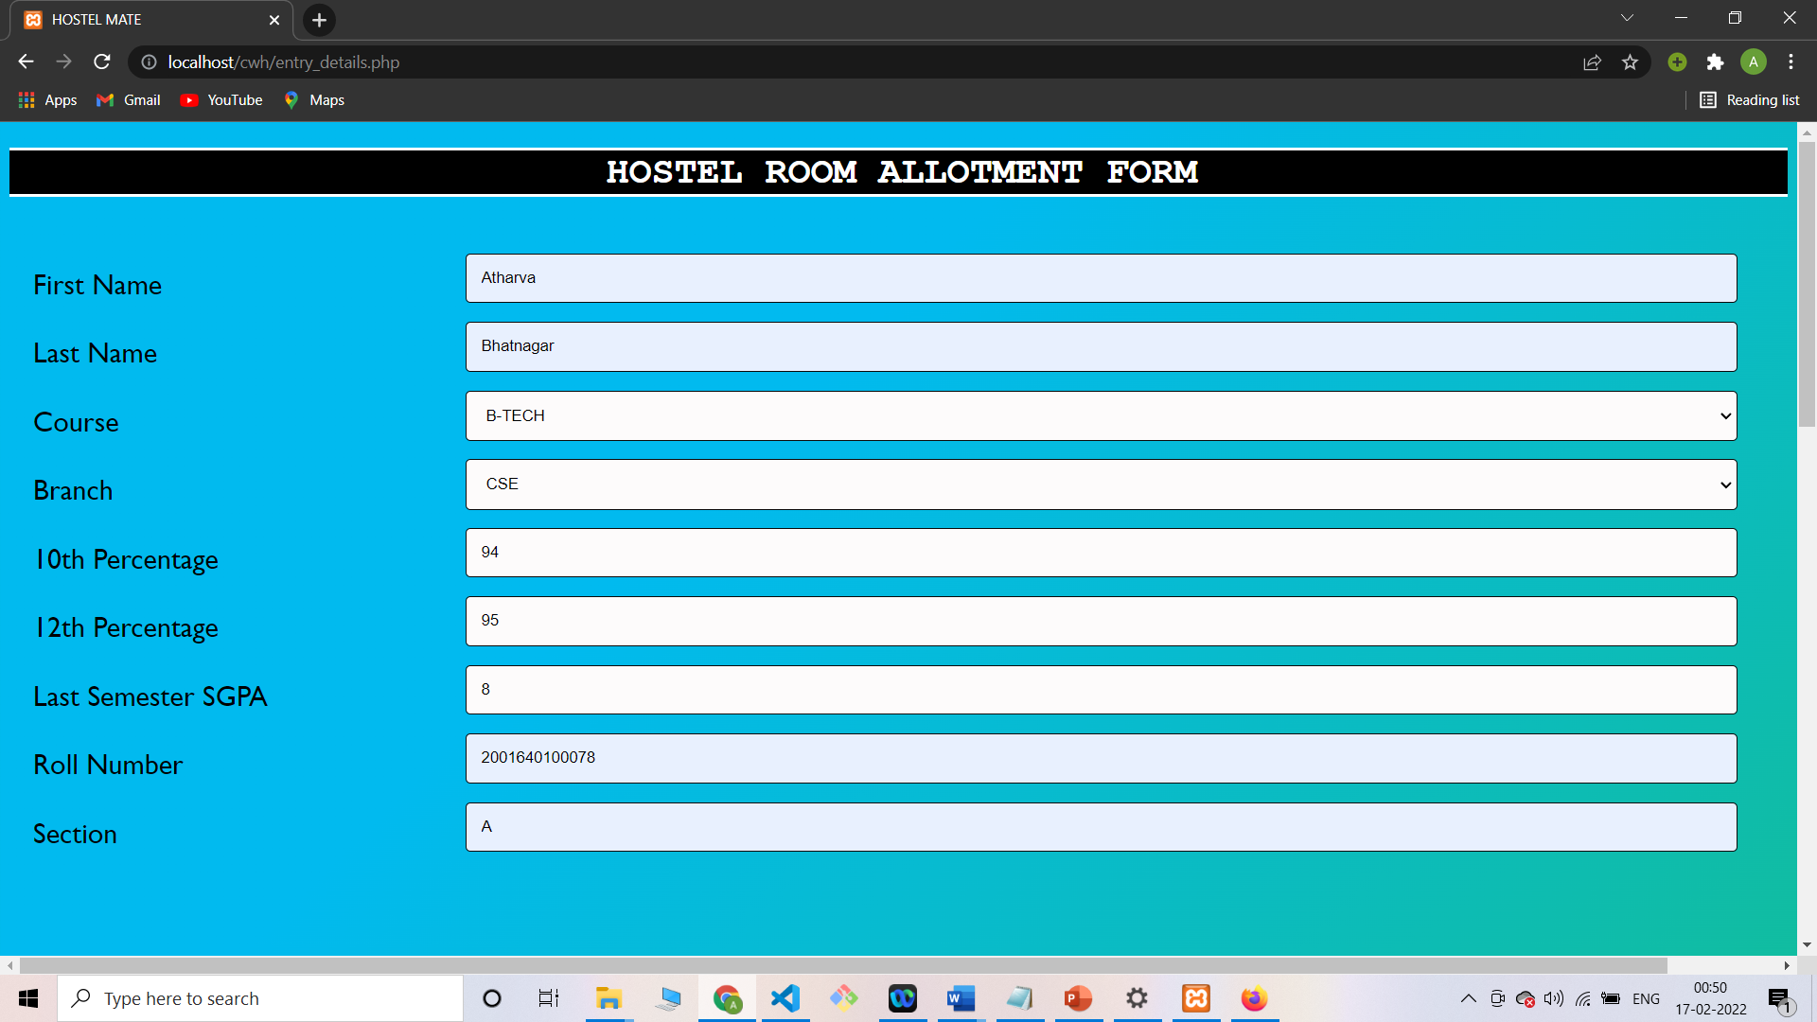
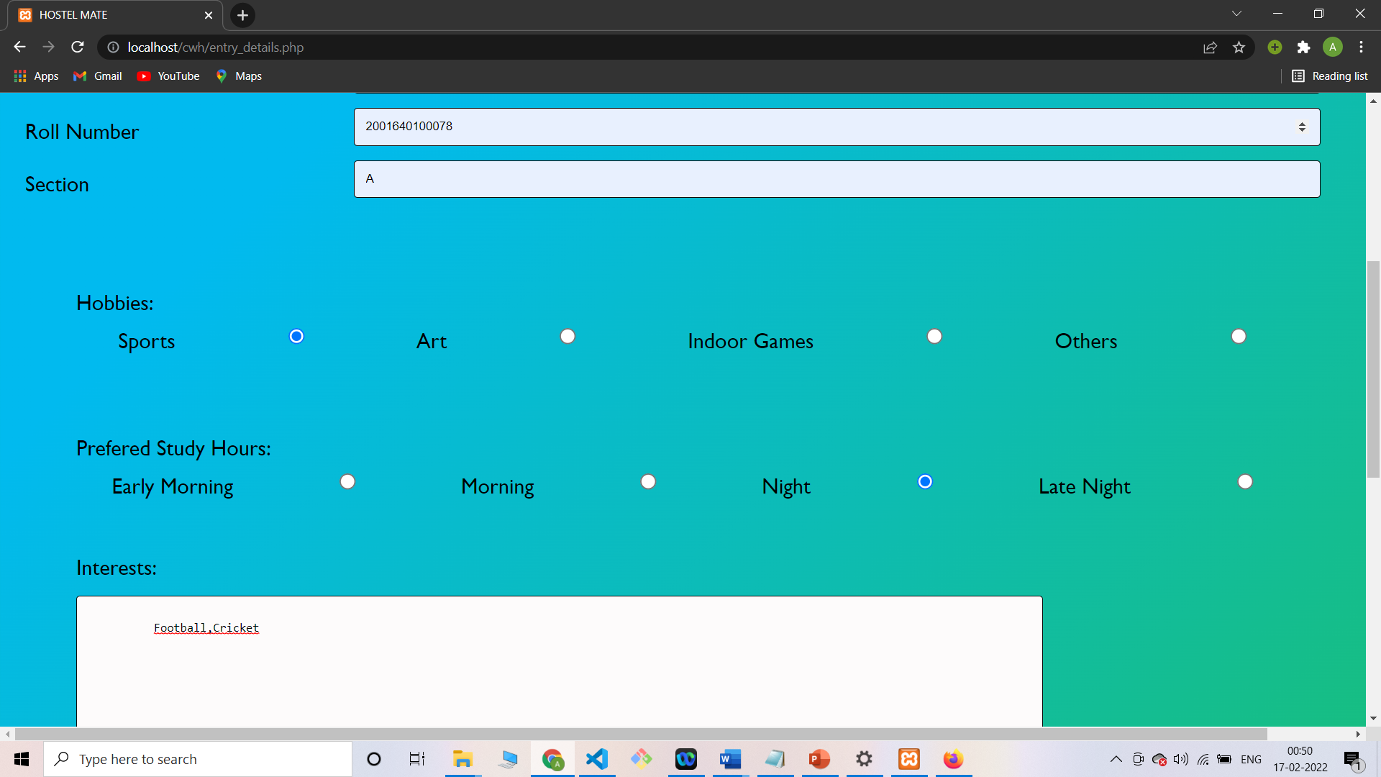

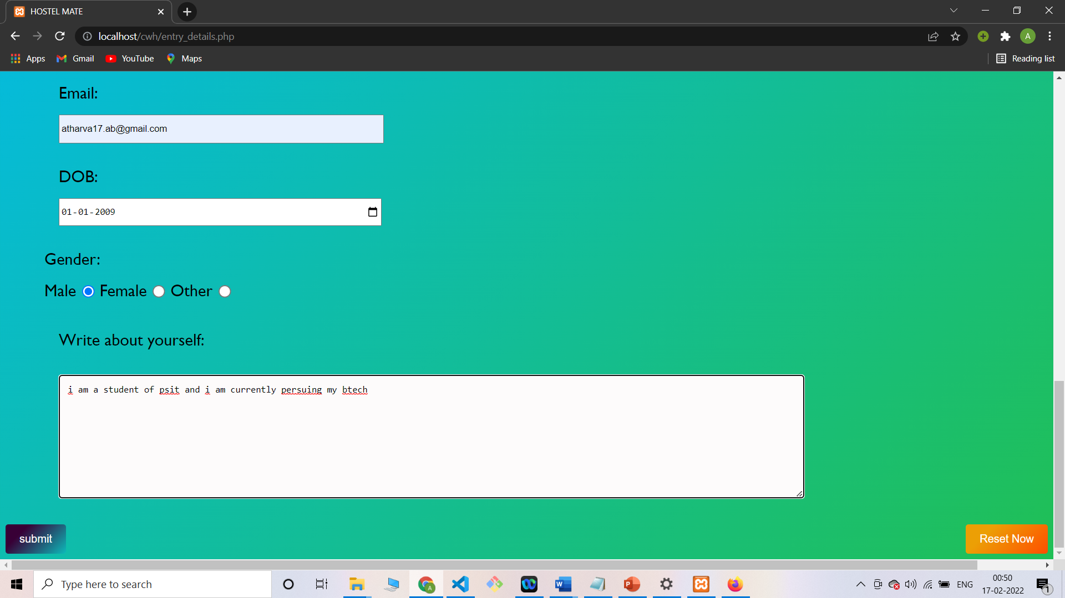

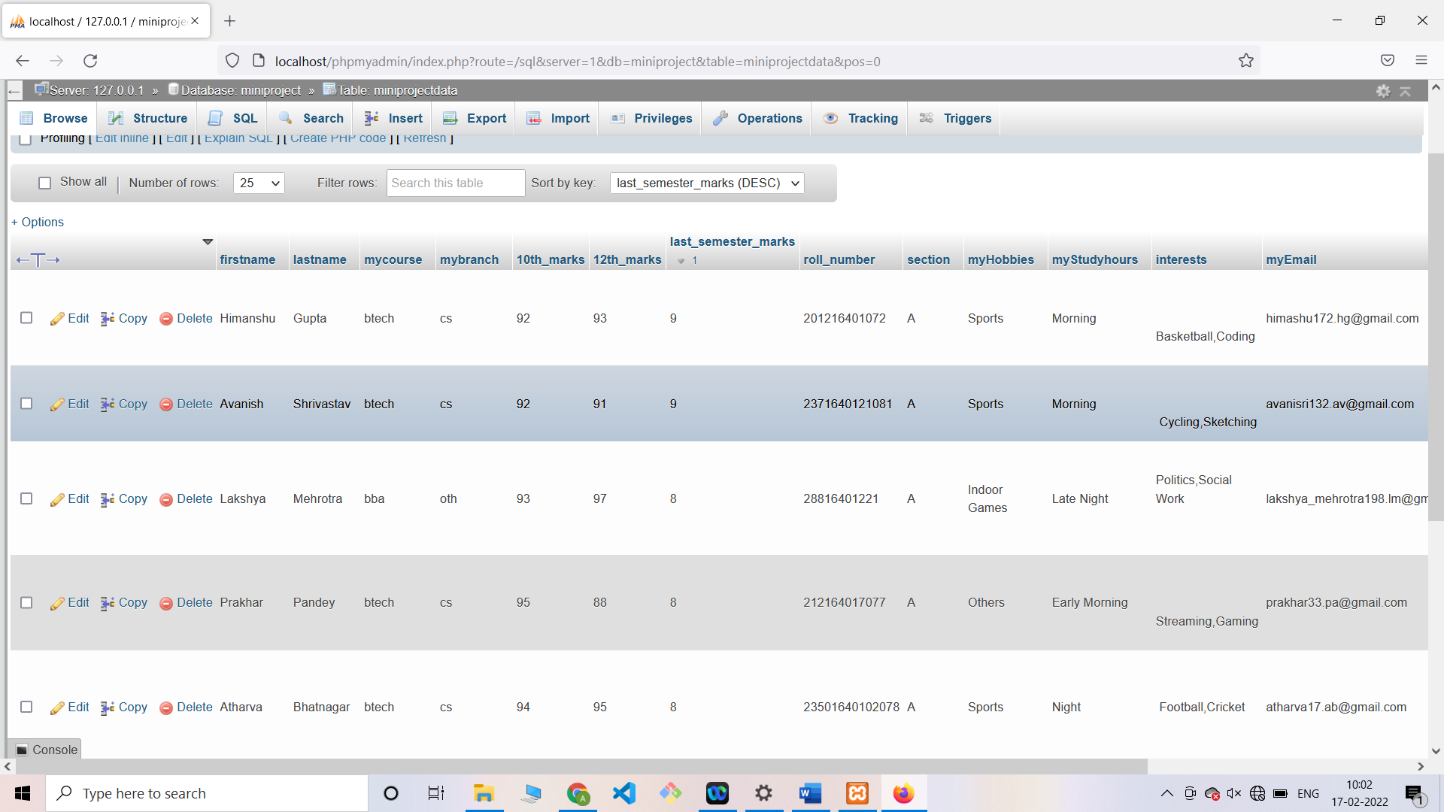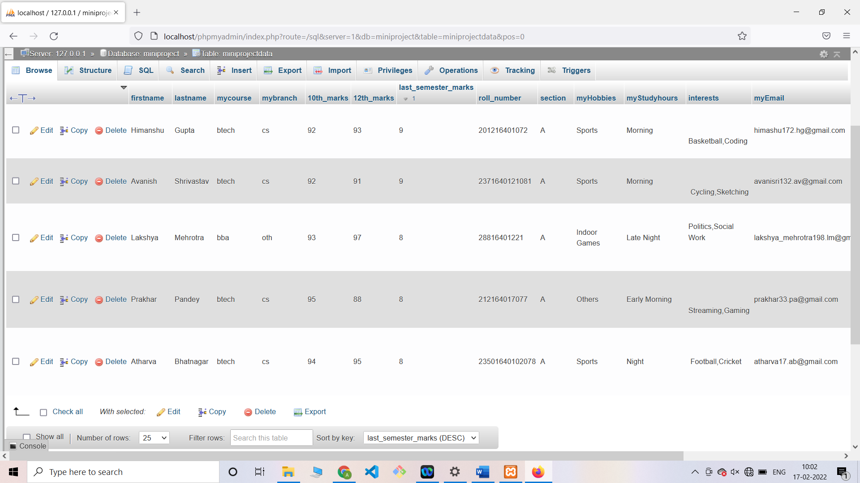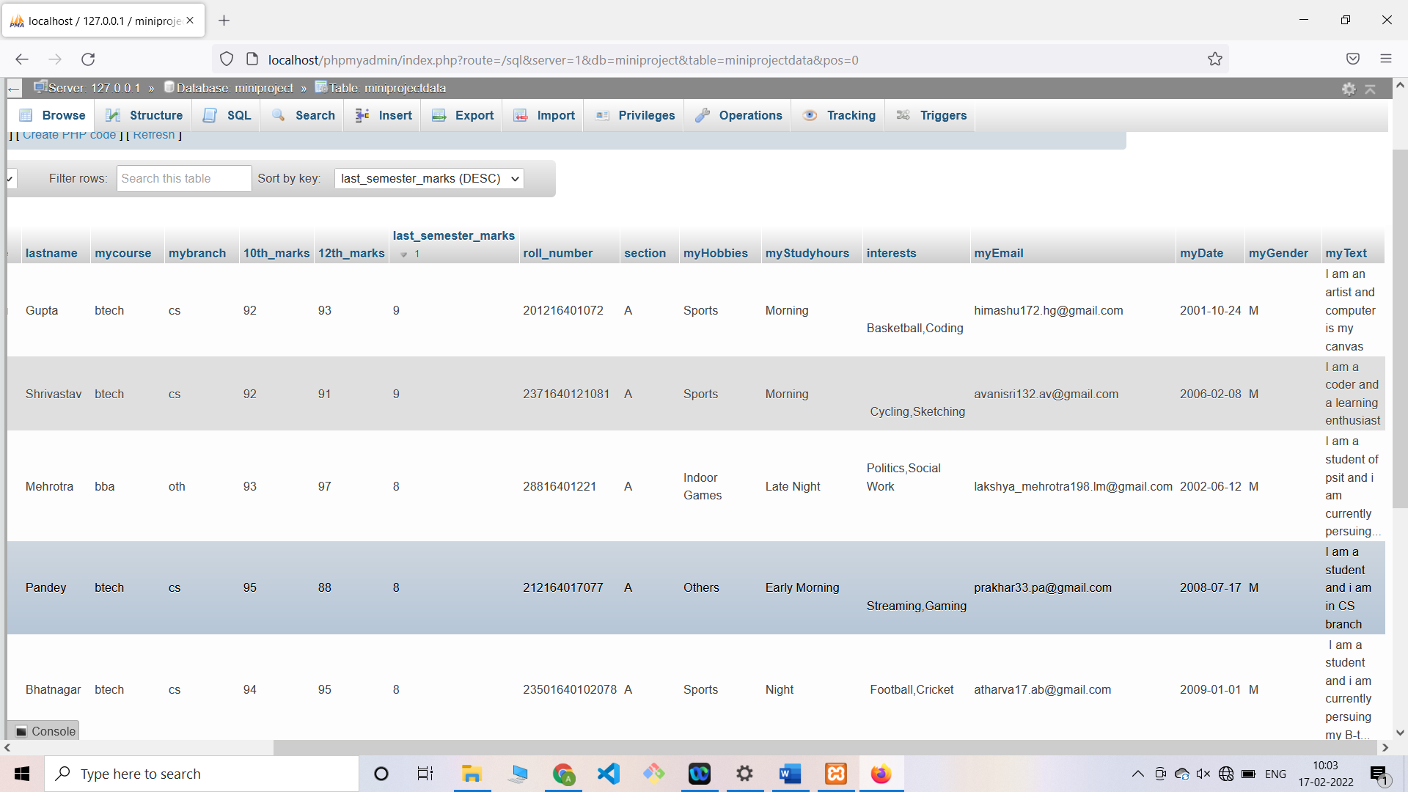
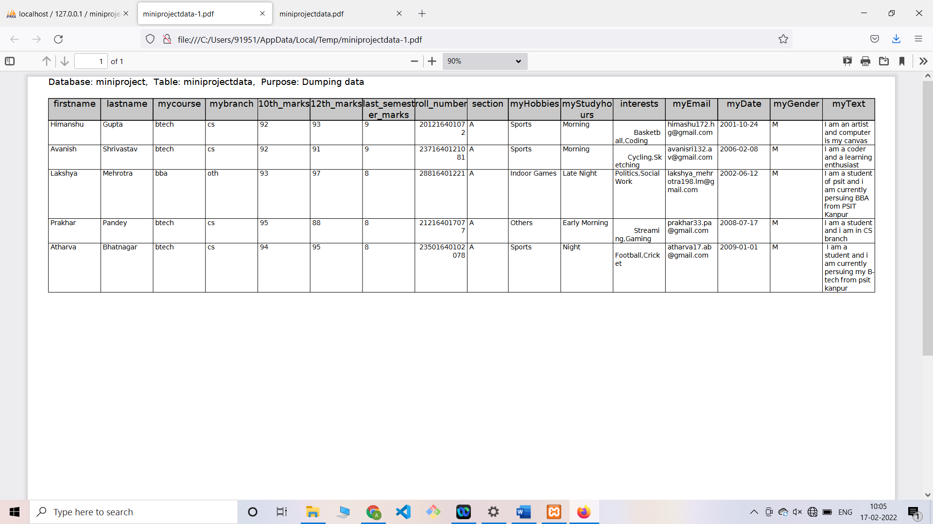

Conclusions and Future Enhancements:

5.1 Advantages of software

1. Cost efficient.
2.Time Efficient.
3. Easy to use.
4. Easy to update and modify the database.
5. User friendly GUI.

5.2 Disadvantages of software

1. Requires Internet Connectivity.
2. Usage Limited to hostels of educational institutes only.
3. Requires a computer.

5.3 Future Enhancements

Currently this project is used for the allocation of hostels in educational institutes based on the data of the students. This project can be further modified and extended for the process of allotment of rental rooms in a PG based on the data of the client as well as this project can also be extended for the allotment of hostels in all the institutes which provides the facilities of hostel and accommodation for e.g.: military bases.

5.4 Conclusion

To conclude the description about the project: The project, developed using HTML, CSS, PHP and MySQL is based on the requirement specification of the user and the analysis of the existing system, with flexibility for future enhancement. The expanded functionality of today’s software requires an appropriate approach towards software development. This hostel management software is designed for people who want to allot rooms in the hostel in a structured manner rather than first come first serve basis. For the past few years, the number of educational institutions is increasing rapidly. Thereby the number of hostels is also increasing for the accommodation of the students studying in this institution. And hence there is a lot of strain on the person who are running the hostel and software’s are not usually used in this context. This particular project deals with the problems on allotment of hostel rooms on first come first serve basis and avoids the problems which occur when carried manually. Identification of the drawbacks of the existing system leads to the designing of computerized system that will be compatible to the existing system with the system which is more user friendly and more GUI oriented.

REFERENCES:

[1] Brad Traversy, Florin Pop 50 Days https://www.udemy.com/certificate/UC-99720bfe-912d-4ab0-bb0f-f0cc0184fa71/ 50 Days 50 Projects – HTML CSS and JavaScript
[2] Code Vault, https://www.youtube.com/watch?v=eUkDdEwUgjs, Form Input Validation in HTML, 18 Jan 2021
[3] W3 Schools, https://www.w3schools.com, HTML, PHP Tutorial, 1999-2022

